Learner participant assent form
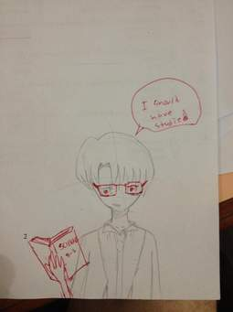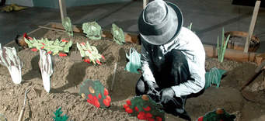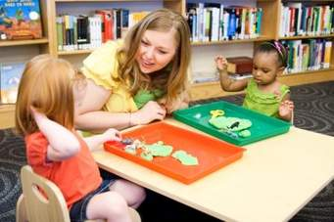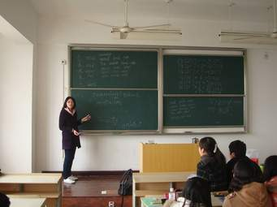
Hello grade 1, I am doing a research cultivate supportive teacher learner relationship with you grad1 I want you to be part of my study

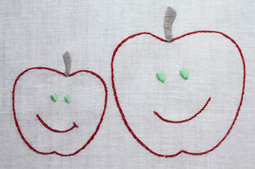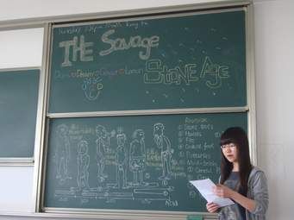
In my study I want you to draw a picture of a teacher you would like have as your grade 1 teacher I would like you to present to us your drawing

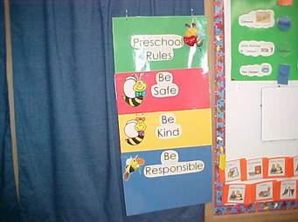
why your teacher is best teacher I will also want you to work in groups to make a collage where you will cut and
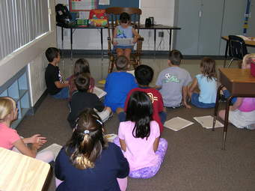

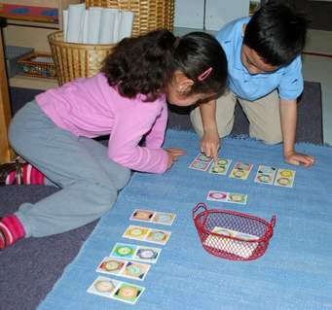 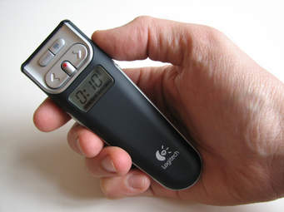paste pictures from magazines or newspapers of things you like about school I will also ask you to present your collage. I will audio record both drawing
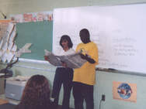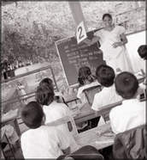
and collage presentation I will also audio record my five teaching lesson with you.
Are you happy or unhappy to be part of my study?
2.8. Validity, Reliability and Rigour: 400 words (in the case of empirical research)

Feldman (2003) maintains that validity is important in self-study research since we engage ourselves in reflective process; as a result we may not be sure of accuracy. According to Feldman (2003, p. 27), “to achieve validity we must provide clear and detailed description of how we collect data”. My thesis will give details of how I will generate data using five data generation practices namely: a) artefact retrieval b) reflective journal writing c) drawing d) collage and e) audio recording of discussions and lessons. The above research practices will help me to recall my personal history and also help me to evaluate my relationships with my grade 1 learners. The use of multiple data generation strategies will help me to improve the validity of the study since each will either confirm or challenge data generated using alternative strategies. For instance, Feldman (2003, p. 28) affirms that “multiple representations that support and challenge one another can add to our reasons to believe and trust the self-study”. Therefore, using multiple data generation practices will enhance the validity of my study.

Moreover, Feldman (2003) believes that a clear presentation of evidence convince readers of the study’s validity. For example, when working with learners in my class, one source of evidence will be their drawings whereby they will try to draw a teacher they would like to have. Such an activity will help me to assess my relationships with my learners and enable me to find means to develop supportive relationships with them. Feldman (2003, p. 28) maintains that “Self-study [should] result in a change in the researcher’s way of being a teacher or teacher educator”. Therefore, evidence of how I change my relationships with learners is required.

